**Name: Gaurang Vaghela**

**Rollno: TEAD-22561**

**DS (SL-III)**

**Practical 7**

**Code:**

**1. Extract Sample document and apply following document preprocessing methods: Tokenization, POS Tagging, stop words removal, Stemming and Lemmatization.**

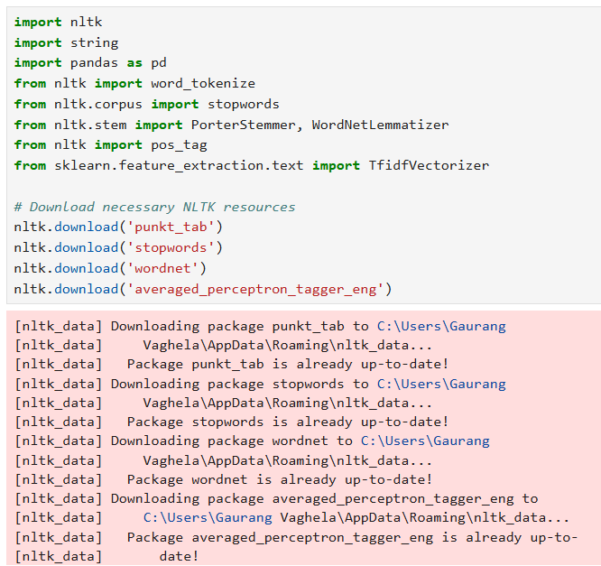

**Tokenization:**

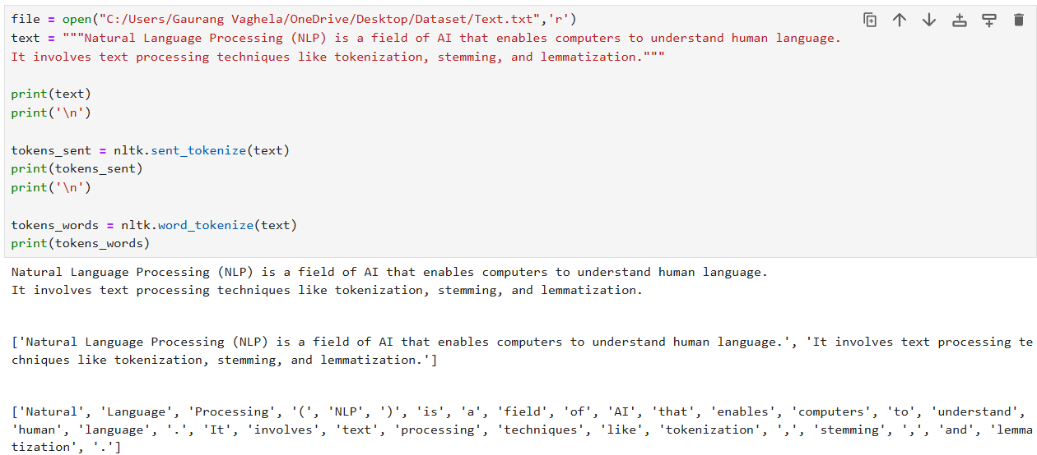

**POS Tagging:**

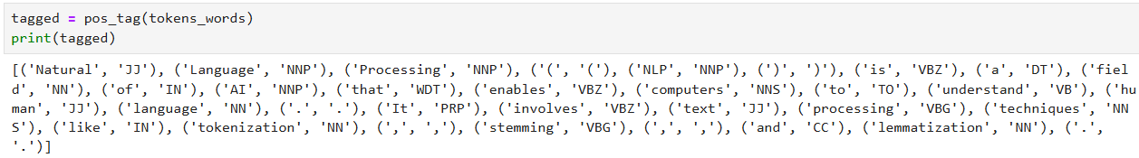

**Stop Words Removing:**

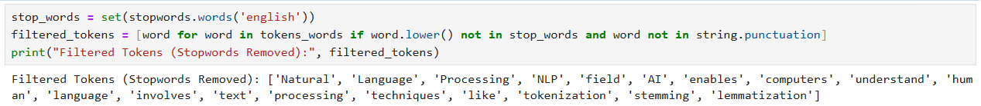

**Stemming:**

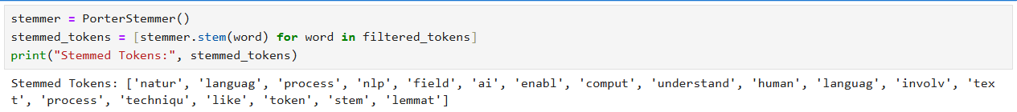

**Lemmatization:**

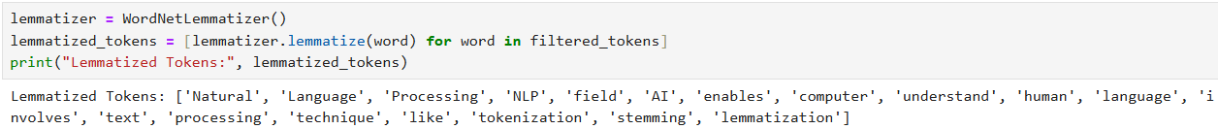

**2. Create representation of documents by calculating Term Frequency and Inverse Document Frequency.**

